Methods

Method has 4 parts

1. Name
2. Input(parameter)
3. Body
4. Return type

In a method there is some task and if I want that task to be executed, then that method has to be brought up into the stack (or) Runtime stack area

Everything done here is with respect to byte code.

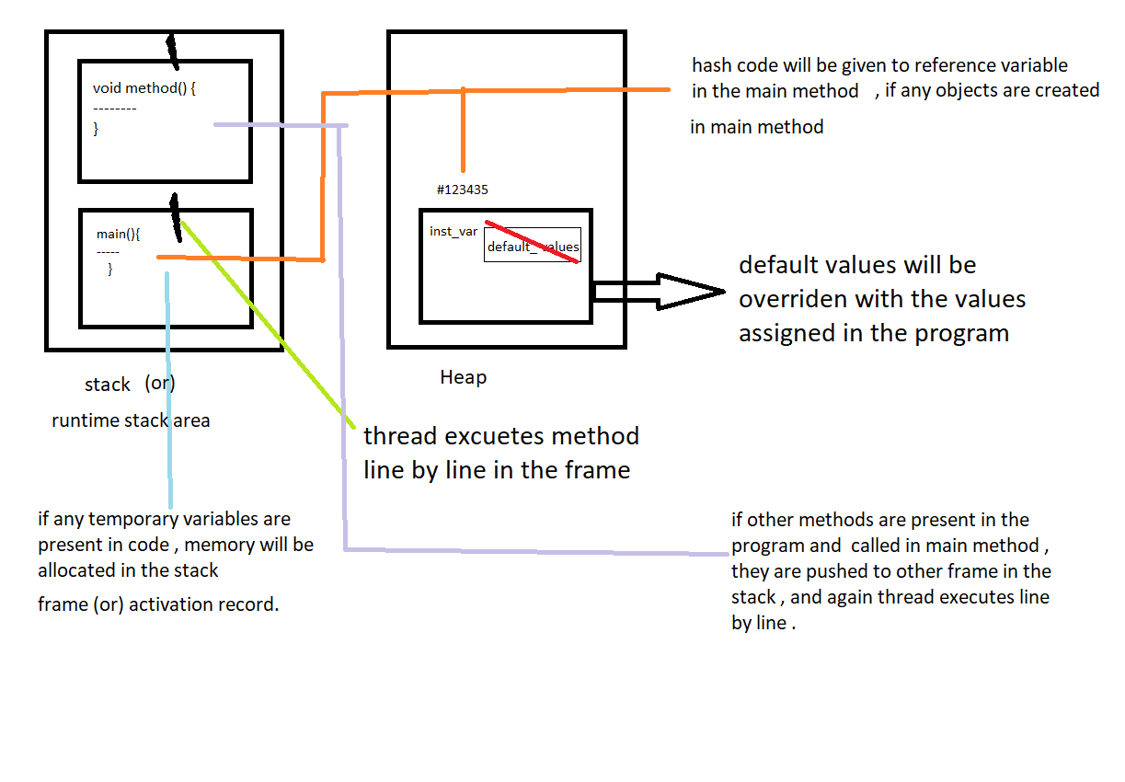

Process:

Check jvm data area picture in previous file

* When the program executes first main method pushes into the stack frame
* Then a thread executes the main method line by line in the activation record
* If any object is present, first R.H.S side is executed in the object.
* Then memory will be created in the heap for instance variables and default values are assigned to them w.r.t to their data types.
* The hash code assigned memory space where the instance variables are stored is sent to reference variable in main method (how hash code sits on reference variable process will be given in constructor)
* If any instance methods present in the program are called in the main method, that method is brought up into another stack frame in run time stack area.
* That method is also executed line by line by a thread.
* After the execution of that whole method, it will be popped out from the run time stack area.
* After execution of all the lines in the main method, it will also be popped out (deleted)
* So there is no reference variable in the stack to hold hash code
* Now garbage collector will check for unreferenced objects and deletes them.

Note: if the method returns anything it is optional whether to collect it or not

Eg: Method_With_Return_Type_And_Parameters

If method is declared with parameters, arguments should be passed compulsory.

Note: // Nested methods are not supported in java. it is supported until java 7 or older version, from java 8 you can achieve it by lambda expression